**Learning Hub**

Design Document

Version 1

27/4/2023

**Revision History**

|  |  |  |  |
| --- | --- | --- | --- |
| **Date** | **Description** | **Author** | **Comments** |
| 27/4/2023 | Version 1 | Hasnaa | Create Design document |

# **1. Introduction**

Learning Hub Web Application is a e-Learning project aims to create an engaging and informative online articles, videos, and records. that helps learners achieve the desired learning outcomes, but this is from the macro perspective. This release will have limited features. Over a period of time, new and new functionalities will be added to the site.

Learning hub is a web platform that will act as an online free encyclopedia hosting tons of information so the users can explore and receive knowledge in different life domain and to be part of the community to contribute and share their knowledge.

1. Generic Diagrams

ERD_001

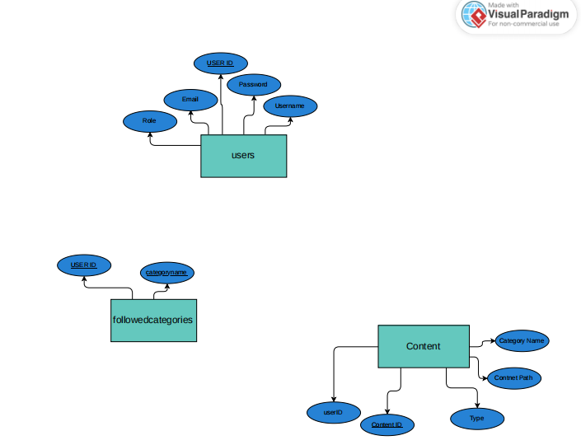

2.2 Use Case

UseCase_001

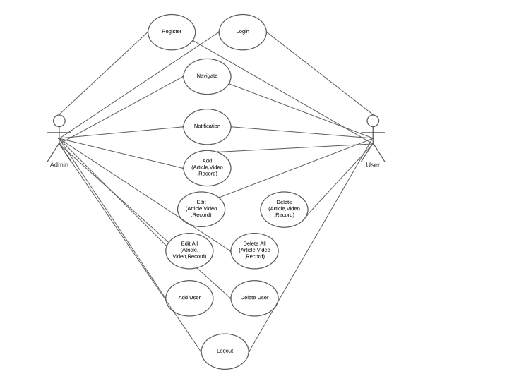

3. Model Based Section

3.1.1 Class Diagram

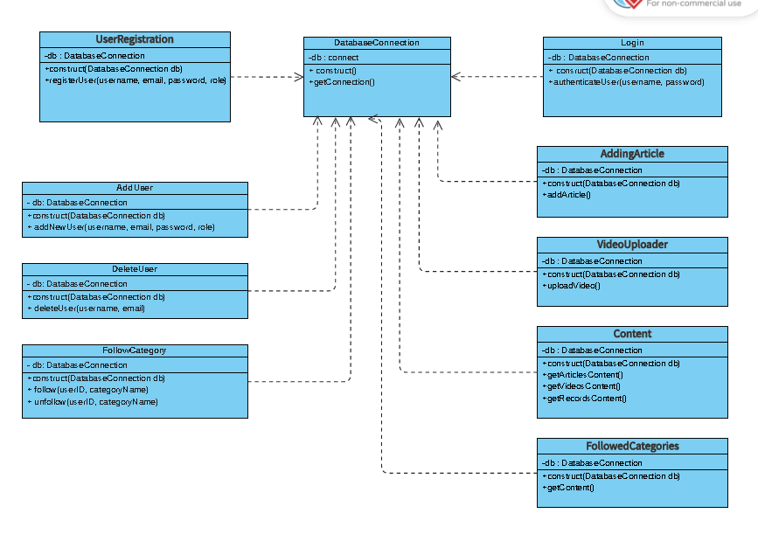

3.1.1 classDiagram_login and Register_001

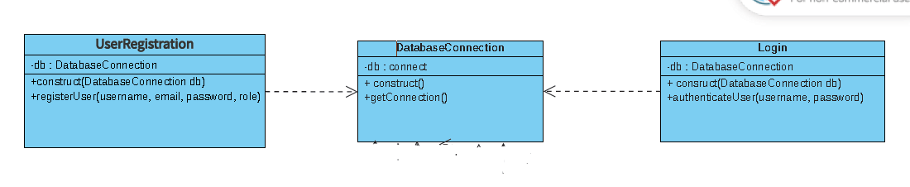

3.1.2 High Level

High_level_login & register

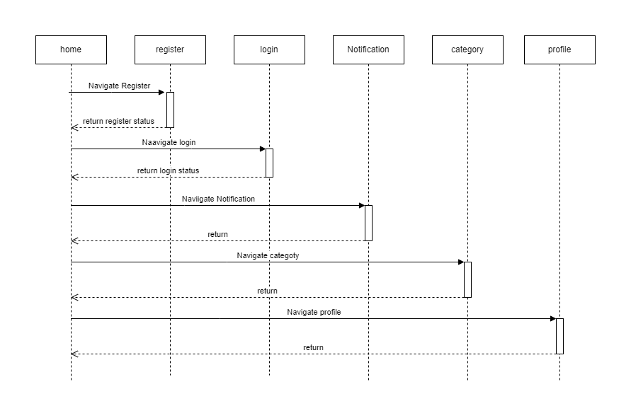

3.1.3 Low Level

Low_Design_login_

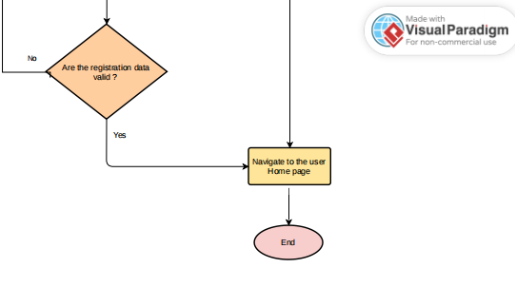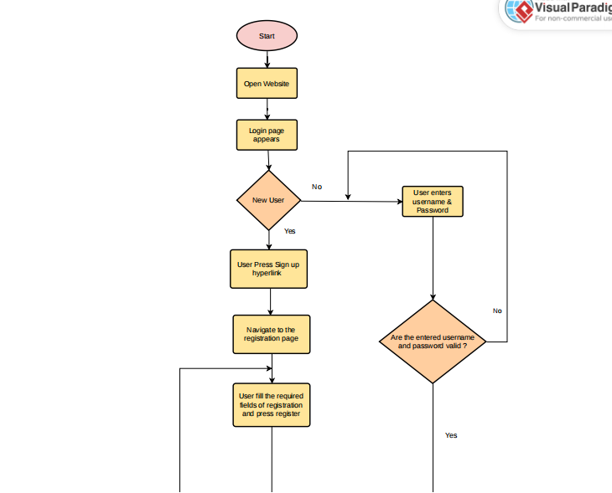

Low_Design_Admin sequence diagram

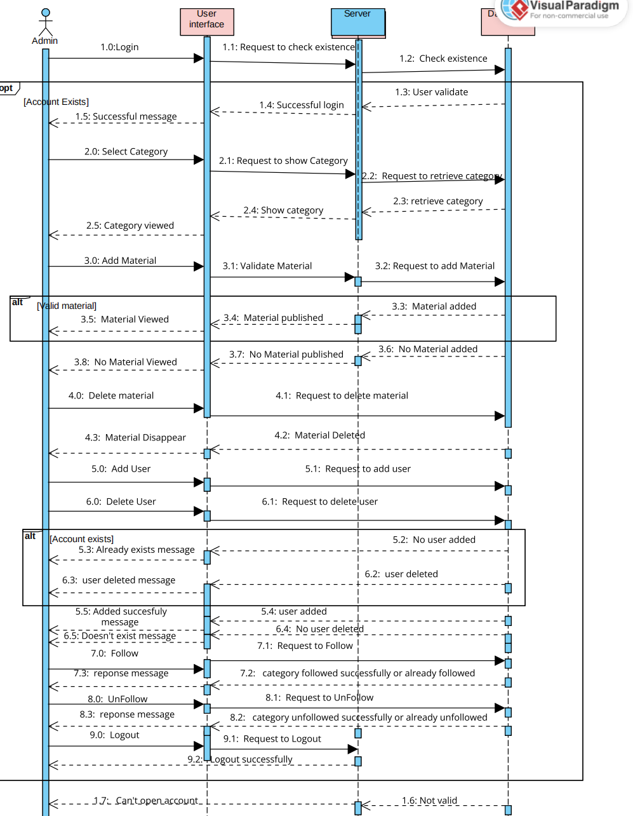

Low_Design_User sequence diagram

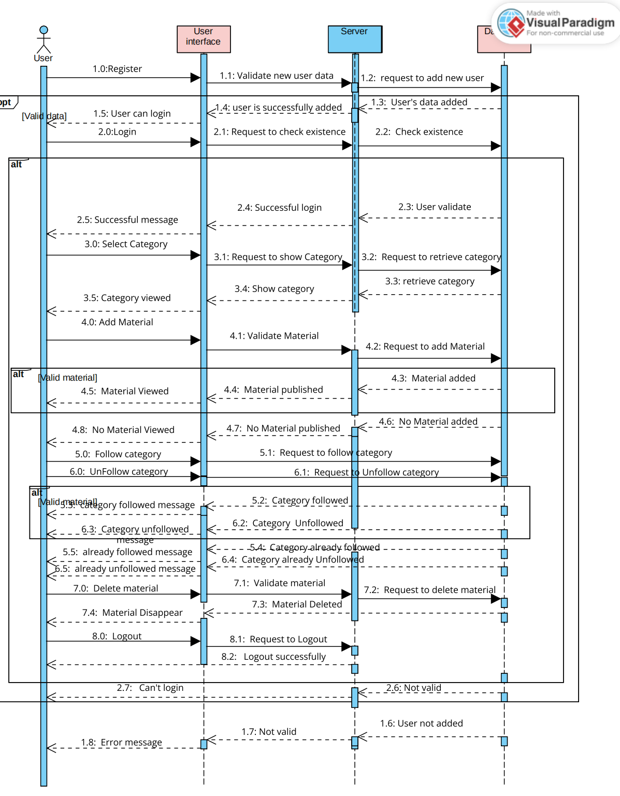

**3.2 Add content**

3.2.1 Class Diagram

classDiagram_Add content_001

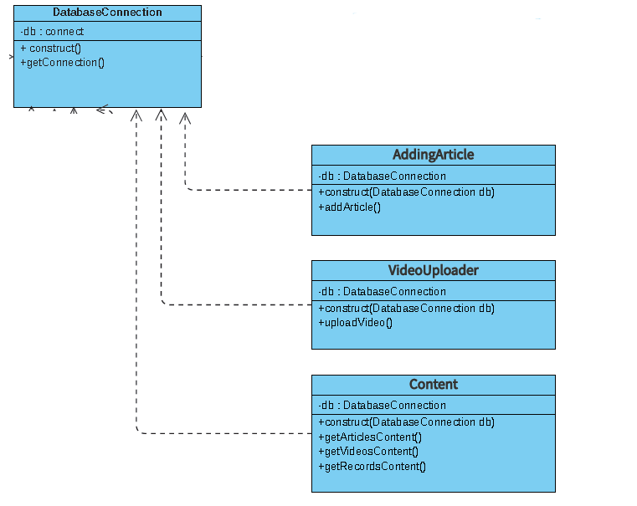

3.2.3 Low Level

Low_Design_add content_1

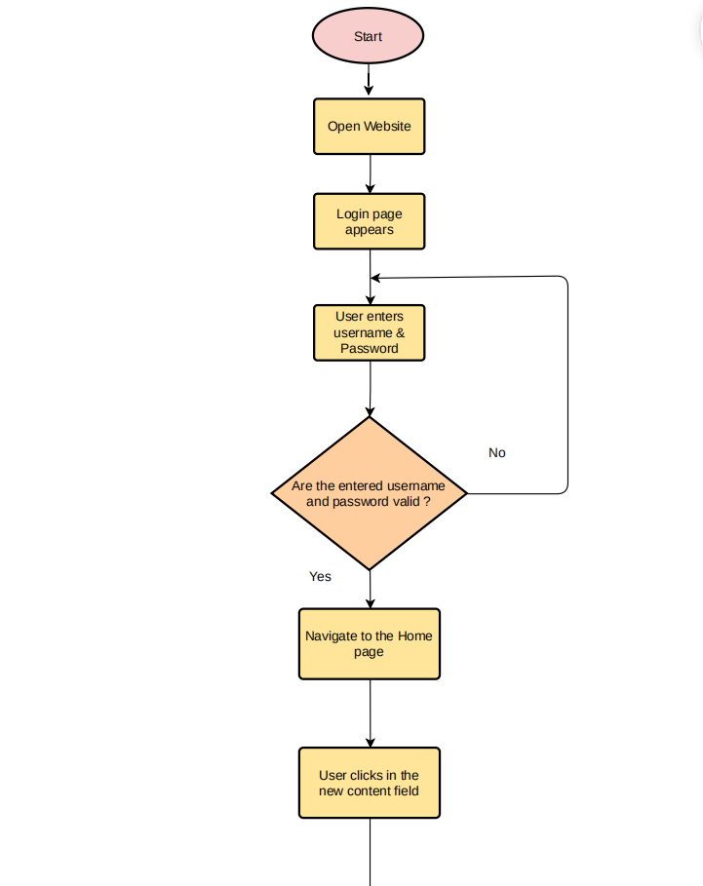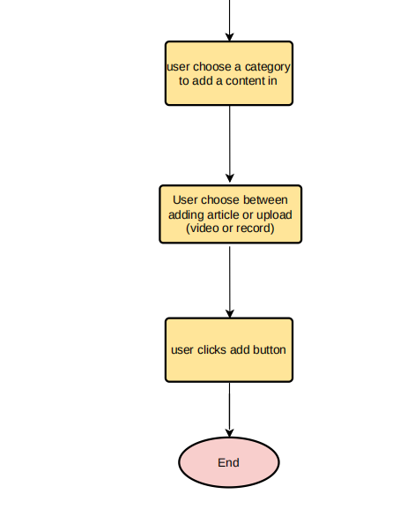

**3.3 Notification page**

3.3.1 Class Diagram

classDiagram_Notification page

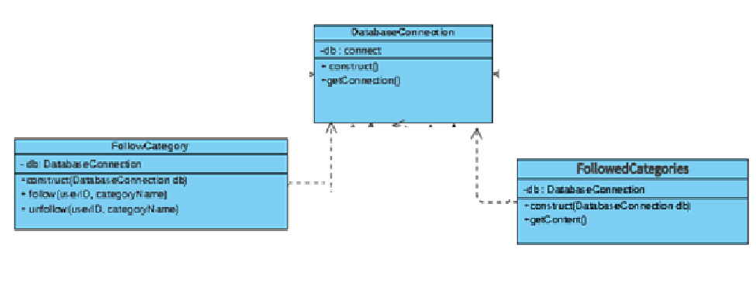

3.3.3 Low Level

Low_Design_Notification

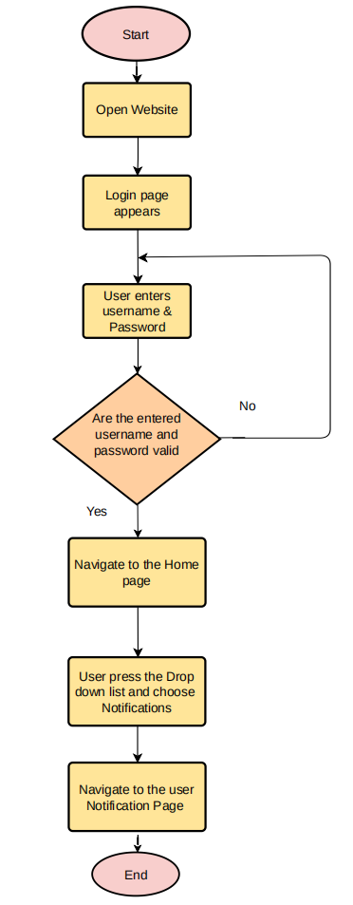

3.4 Add content

3.4.1 Class Diagram

classDiagram_Add content

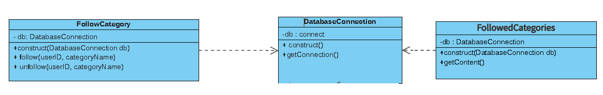

Low level

Low_Design_Add content

